­­­­­­­

# Informe previo Práctica-4

Apellidos y nombre: .......................................Miquel Torner Viñals.......................................... Grupo: ..73..

(por orden alfabético)

#### Pregunta 1

|  |  |  |  |  |  |  |  |  |  |  |  |  |  |  |  |  |  |  |  |  |  |  |
| --- | --- | --- | --- | --- | --- | --- | --- | --- | --- | --- | --- | --- | --- | --- | --- | --- | --- | --- | --- | --- | --- | --- |
|  | @A | | | | @B | | | Rb/N | OP | | F | | | In/Alu | @D | | | WrD | N  (**Hexa**) | | | |
| b2 | | b1 | b0 | b2 | b1 | b0 | b1 | b0 | b2 | b1 | b0 | b2 | b1 | b0 | D3 | D2 | D1 | D0 |
| AND R3, R1, R5 | 0 | | 0 | 1 | 1 | 0 | 1 | 1 | 0 | 0 | 0 | 0 | 0 | 0 | 0 | 1 | 1 | 1 | X | X | X | X |
| ADD R1, R2, R3 // NOT R2, R1 |  |  |  |  |  |  |  |  |  |  |  |  |  |  |  |  |  |  |  |  |  |  |
|  |  |  |  |  |  |  |  |  |  |  |  |  |  |  |  |  |  |  |  |  |
| SHAI R7, R7, -3 | 1 | | 1 | 1 | X | X | X | 0 | 0 | 0 | 1 | 1 | 0 | 0 | 1 | 1 | 1 | 1 | F | F | F | D |
| ADDI R4, R7, -1 | 1 | | 1 | 1 | X | X | X | 0 | 0 | 0 | 1 | 0 | 0 | 0 | 1 | 0 | 0 | 1 | F | F | F | F |
| OUT R5 // IN R6 | 1 | | 0 | 1 | X | X | X | X | X | X | X | X | X | 1 | 1 | 1 | 0 | 1 | X | X | X | X |
| IN R1 // ADD R2, R3, R7 |  | |  |  |  |  |  |  |  |  |  |  |  |  |  |  |  |  |  |  |  |  |
| MOVEI R3, 327 | X | | X | X | X | X | X | 0 | 1 | 0 | 0 | 0 | 1 | 0 | 0 | 1 | 1 | 1 | 0 | 1 | 4 | 7 |
| SHLI R6, R6, 1 | 1 | | 1 | 0 | X | X | X | 0 | 0 | 0 | 1 | 1 | 1 | 0 | 1 | 1 | 0 | 1 | 0 | 0 | 0 | 1 |
| CMPEQ -, R3, R2 | 0 | | 1 | 1 | 0 | 1 | 0 | 1 | 0 | 1 | 0 | 1 | 1 | X | X | X | X | 0 | X | X | X | X |
| SUBI -, R2, 1 | 0 | | 1 | 0 | X | X | X | 0 | 0 | 0 | 1 | 0 | 1 | X | X | X | X | 0 | 0 | 0 | 0 | 1 |

IN R1 // ADD R2, R3, R7 no es pot dur a terme ja que per fer-ho la nostra ALU hauria de ser capaç d’escriure dos valors en el banc de registres simultàniament.

**Pregunta 2**

|  |  |
| --- | --- |
| Mnemotécnico | Palabra de control hexadecimal |
| AND R3, R1, R5 | 06C070000 |
| ADD R1, R2, R3 // NOT R2, R1 | -------------- |
| SHAI R7, R7, -3 | 1C0CFFFFD |
| ADDI R4, R7, -1 | 1C089FFFF |
| OUT R5 // IN R6 | 1401D0000 |
| IN R1 // ADD R2, R3, R7 | -------------- |
| MOVEI R3, 327 | 002270147 |
| SHLI R6, R6, 1 | 180ED0001 |
| CMPEQ -, R3, R2 | 0D5600000 |
| SUBI -, R2, 1 | 080A00001 |

**Pregunta 3**

* + 1. AND R3, R1, R5

**Respuesta:** R3 = 0

* + 1. ADD R1, R2, R3 // NOT R2, R1

**Respuesta:** -------

* + 1. SHAI R7, R7, -3

R7 = 1

* + 1. ADDI R4, R7, -1

R4 = 9

* + 1. OUT R5 // IN R6

R6 = 23

* + 1. MOVEI R3, 327

R3 = 327

* + 1. IN R1 // ADD R2, R3, R7

--------

* + 1. SHLI R6, R6, 1

R6 = 18

* + 1. CMPEQ -, R3, R2

-------- (No es modifica cap registre)

* + 1. SUBI -, R2, 1

-------- (No es modifica cap registre)

#### Pregunta 4

###### a) Ya está resuelto en el enunciado

b) **if** (R1 != 1)

R2 = R2 + R2;

###### else

R2 = R2 + 5;

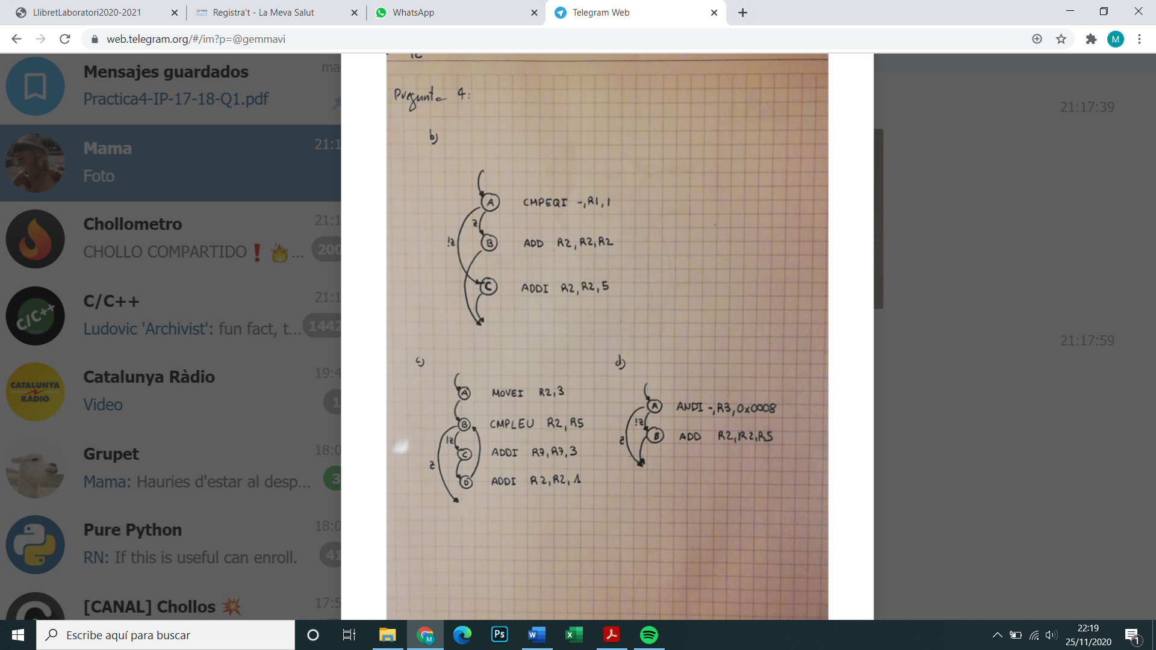

c) **for** (R2 = 3; R2 <= R5; R2 = R2+1) R7 = R7 + 3;



d) **if** (R1<3> = 1) R2 = R2 + R5;

(Nota: R1<3> se refiere al bit 3 del registro R1. La acción ANDI de R3 con un valor inmediato adecuado da como resultado 0 si el bit 3 de R1 vale 0 y distinto de 0 si vale 1).



#### Pregunta 5

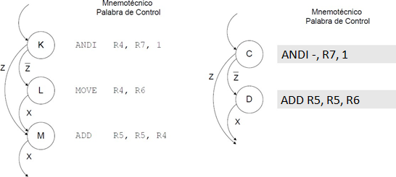

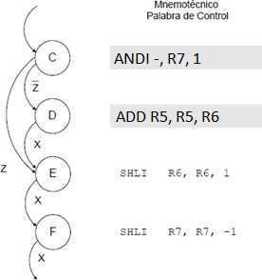

**Pregunta 6**

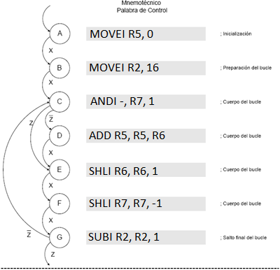

**Pregunta 7**

|  |  |  |  |  |  |
| --- | --- | --- | --- | --- | --- |
| **Ciclo** | **Mnemotécnico** | **Estado actual de los registros** | | | |
| **R2** | **R5** | **R6** | **R7** |
| 0 | MOVEI R5, 0 | X X X X | X X X X | 0 0 1 1 | 0 1 0 1 |
| 1 | MOVEI R2, 4 |  | 0 0 0 0 |  |  |
| 2 | ANDI -, R7, 1 | 0 1 0 0 |  |  |  |
| 3 | ADD R5, R5, R6 |  |  |  |  |
| 4 | SHLI R6, R6, 1 |  | 0011 |  |  |
| 5 | SHLI R7, R7, -1 |  |  | 0110 |  |
| 6 | SUBI R2, R2, 1 |  |  |  | 0010 |
| 7 | ANDI -, R7, 1 | 0011 |  |  |  |
| 8 | SHLI R6, R6, 1 |  |  |  |  |
| 9 | SHLI R7, R7, -1 |  |  | 1100 |  |
| 10 | SUBI R2, R2, 1 |  |  |  | 0001 |
| 11 | ANDI -, R7, 1 | 0010 |  |  |  |
| 12 | ADD R5, R5, R6 |  |  |  |  |
| 13 | SHLI R6, R6, 1 |  | 1111 |  |  |
| 14 | SHLI R7, R7, -1 |  |  | 1000 |  |
| 15 | SUBI R2, R2, 1 |  |  |  | 0000 |
| 16 | ANDI -, R7, 1 | 0001 |  |  |  |
| 17 | SHLI R6, R6, 1 |  |  |  |  |
| 18 | SHLI R7, R7, -1 |  |  | 0000 |  |
| 19 | SUBI R2, R2, 1 |  |  |  | 0000 |

1. ¿Cuántos ciclos tarda en ejecutarse el algoritmo?

Triga 20 cicles a executar-se

1. ¿Cuál es el estado de la UPG (el valor de los registros de la UPG) después de ejecutarse el algoritmo?

R2 = 0000; R5 = 1111; R6 = 0000; R7 = 0000

#### Pregunta 8

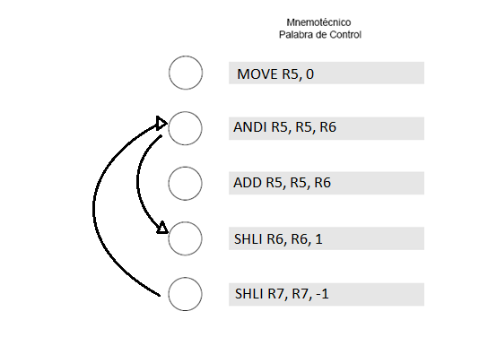

-, R7, 1

! z

z

! z

z

F

E

D

C

B

**Pregunta 9**

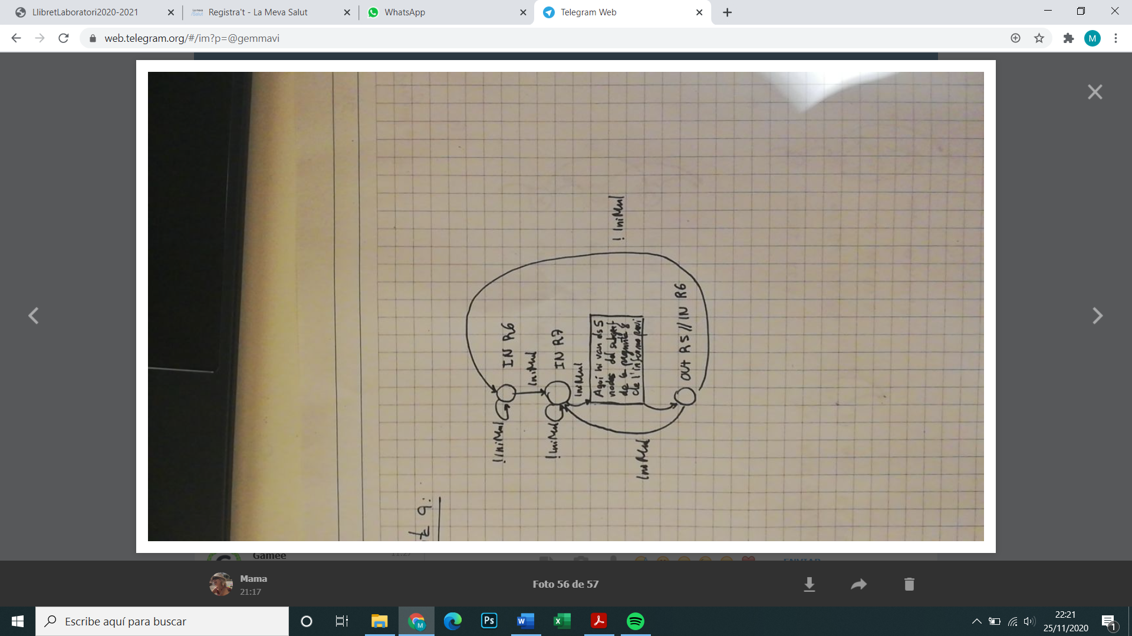

**Pregunta 10**

|  |
| --- |
| **ROM_Q+_MUL** |
| **0x0 0x0 0x1 0x1**  **0x1 0x1 0x2 0x2**  **0x3 0x3 0x3 0x3**  **0x4 0x5 0x4 0x5**  **0x5 0x5 0x5 0x5**  **0x6 0x6 0x6 0x6**  **0x3 0x7 0x3 0x7**  **0x0 0x1 0x0 0x1** |

|  |
| --- |
| **ROM_OUT_MUL** |
| **0x1E00000000**  **0x1F00000000**  **0x0D11000000**  **0x00E0000010**  **0x0DA4E00000**  **0x0EC7000010**  **0x0FE70FFFF0**  **0x1EA0000001** |